**Classroom Session: Extract the Value of *sys_id*  from Create Incident and Save as Global Variable**

**Learning Objective:**  
The objective of this session is to learn how to extract the sys_id from the response of a create incident request in ServiceNow and save it as a global variable in Postman.

**Expected Completion Time:**

* Best Case: 20 minutes
* Average Case: 30 minutes

**Session Details:**

**ServiceNow API Credentials:**

1. **Obtain Your ServiceNow Instance Credentials:**
   * Instance URL
   * Username
   * Password

**Extracting sys_id from Create Incident Response:**

**Step 1: Create a new Blank Collection**

* Create New Collection .

**Step 2: Create a New Request**

* Click on "New" and select "HTTP Request".
* Name your request appropriately, e.g., "Create Incident".

**Step 3: Set Up the Request URL**

* Set the request type to POST.
* Enter the ServiceNow API endpoint for creating an incident:

**POST** https://<your_instance>.service-now.com/api/now/table/incident

* Replace <your_instance> with your ServiceNow instance name.

**Step 4: Authentication**

* Go to the "Authorization" tab.
* Select "Basic Auth".
* Enter your ServiceNow Username and Password.

**Step 5: Check the Headers**

* Navigate to the "Headers" tab.
* Check following header:
  + Key: ***Content-Type*** Value: ***application/json***

**Step 6: Body**

* Switch to the "**Body**" tab.
* Select raw and choose JSON from the drop-down menu.
* Enter the JSON payload for creating an incident. Example:

{

  "short_description": "Test incident creation",

  "description": "Software

}

**Step 7: Send the Request**

* Click "Send".
* Observe the response in the lower pane **Body**. Ensure it contains the details of the newly created incident, including the sys_id.

**Step 8: Save the Response as a Variable**

* Go to the "**Scripts**" tab and add the following script to save the response as a variable:

var resp = pm.response.json();

**Step 9: Traverse Through the Response to Find sys_id Path**

* Use [JSONPath Finder](https://jsonpathfinder.com/) to locate the path of sys_id in the response. For example:

x.result.sys_id

**Step 10: Extract sys_id and Save as Local Variable**

* Extract the sys_id from the response and save it as a local variable:

var sysid = resp.result.sys_id;

**Step 11: Save the sys_id as Global Variable**

* Create global variable by clicking **Environments** click **Globals** the create a global variable named ***systemid***
* Save the value of sys_id as a global variable in Postman:

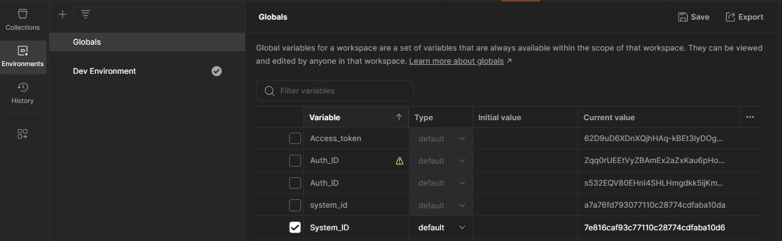

pm.globals.set("systemid", sysid);

**Step 12: Send the Request and Validate**

* Click "Send" again to execute the request and ensure the sys_id is saved correctly as a global variable.
* You can verify the sys_id in the console by printing using this code

console.log(sys_id)

**Expected Outcome:**

Upon completion, you should be able to:

* Create an incident in ServiceNow via API.
* Extract the sys_id from the response of the create incident request.
* Save the extracted sys_id as a global variable in Postman for use in subsequent requests.